EEE-313 LAB 1

Sait Sarper Özaslan

22002861

Introduction

The aim of this lab is to use an LED, photodiode and OPAMP to create a half rectified sinusoidal wave that will be converted into DC voltage through the usage of diode, capacitor and resistors.

1. LEDs, Photodiodes and Circuit Working Principle

1.1 LED

LED, which stands for light emitting diode, converts current to light [1]. The LED used in this lab needs to emit photons so that the diode works which means its semiconductor material is made out of direct bandgap material. Essentially a direct bandgap material allows hole and electron to combine when electricity is applied which allows photon or light emitting.

1.2 Photodiode

Photodiode is a device that converts optical signals into electrical signals [1]. It’s pn junction operates in reverse-bias voltage. Photons or light waves that come to photodiode create electrons and holes which afterwards turns into a current called photocurrent. Generated current is proportional to electric flux.

1.3 Working Principle

Essentially a voltage needs to be created on the output of the OPAMP through the usage of photocurrent, R2 and OPAMP. OPAMP transforms the current from photodiode into voltage. The output voltage of OPAMP is expected to be,

$$R2⋅I_{photo}=V_{opamp}$$

The output of photo diode is half rectified due to LED cutting of the forward bias. Therefore, the output OPAMP is expected to be half rectified sinusoidal wave.

The next part of the circuit essentially does the work of converting the half rectified sinusoidal wave into DC voltage. Essentially the circuit that is composed of R3, C1 and diode is used as an AC-DC converter. The working mechanism of the circuit essentially relies on the time constant $$τ=R_{3}C_{1}$$.

When voltage higher than threshold voltage of diode is delivered to R3 and C1 the capacitor starts to charge up. When voltage drops to levels where no voltage can be supplied to this part of the circuit, Capacitor starts discharging to R3. The diode acts as a reverse voltage protection in this state. To be able to achieve a steady DC voltage, OPAMP needs to start supplying voltage before C1 fully can discharge. This will create a ripple effect on the output allowing us to approximate the resulting voltage into DC voltage. In short, the goal is to achieve ripple approximation on the final output.

1. Pd333-3v/h0/l2 Photodiode and SB-5010IRB LED

The LED works at 940nm while the photodiode can detect light wavelength between 840 and 1100 [2,3] . The circuit is chosen to work at nonvisible light so that there would be less interference from external circumstance such as a light in the lab.

Hardware Implementation and Analysis

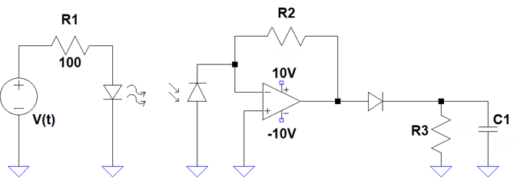

Figure 1: Circuit to be used in this lab

Here are the specifications for this lab:

$$V_{input}= 3\left(\sin\left(2π⋅1000\right)\right)$$

$$R2=47k Ohm$$

$$R3=100k Ohm$$

$$C1=1μ Farad$$

* 1n4148 diode
* OPAMP voltage in between +10V and –10V

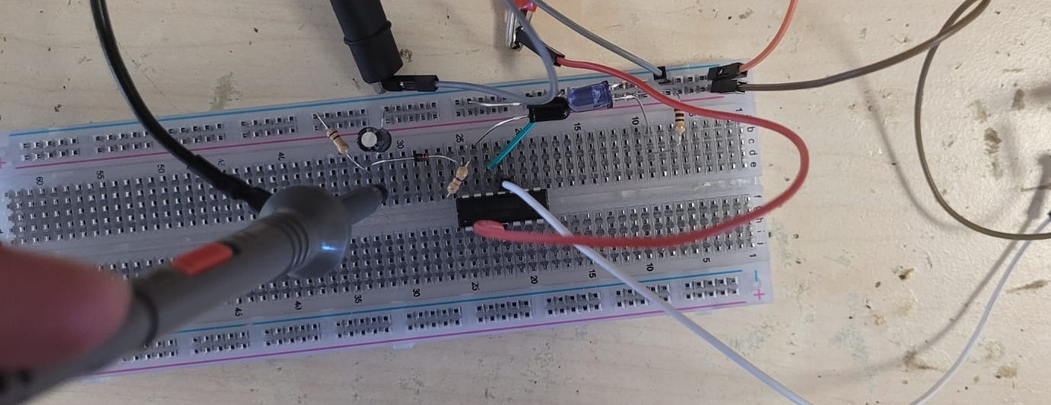

Figure 2: Circuit used in the lab

1. LED Output

The forward biased LED’s state can be explained in two states: ON and OFF state. The diode will turn on when the threshold voltage is met and will be able to emit transmit IR radiation: In this case the circuit will essentially look like this:

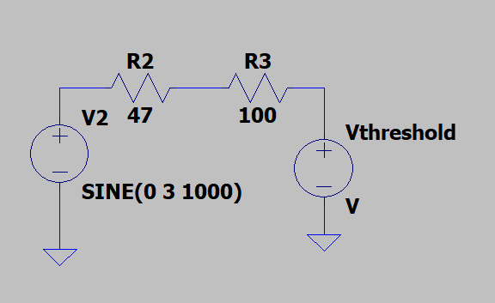

Figure 3: LED on ON Condition

In this case the LED’s output will just show the threshold voltage and the voltage will not change much until the input voltage can’t supply more than the threshold voltage.

Once the voltage falls below the threshold voltage. The circuit behaves like an open circuit. This means the diode’s output will imitate the input voltage as there is no current flow. In such case one will expect to see a result like this:

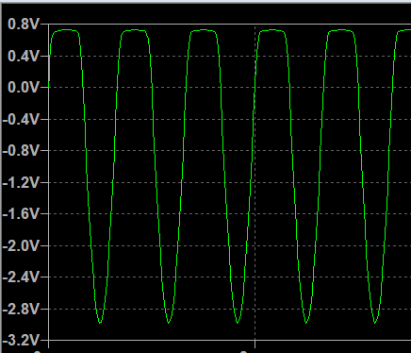

Figure 4: LED’s output on LTSpice

It should be noted that a basic diode was used to imitate the characteristics of LED on LTSpice and any value seen on the simulation does not correspond to actual circuit’s LED output.

Here is the hardware circuit’s LED output for comparison:

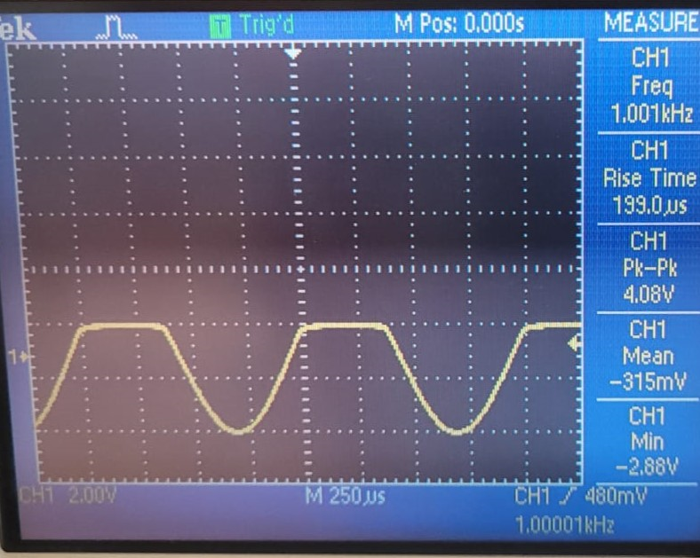

Figure 5: LED’s Output on Breadboard

As one can see, the minimum voltage is close to –3Volts which is the input and the voltage stabilized around 1.2V when threshold voltage is surpassed.

* The transmitted and received IR radiation can be maximized by putting the head of the diodes towards each other and as close as possible. This will allow photodiode to receive as much current IR radiation as possible. This can be seen in figure 2 where LED and Photodiode’s heads are touching each other and as close as possible to maximize the current.

1. Decision for R2

Looking at the datasheet of the photodiode it says that there will be 35 current per 1mW/cm2. Since the voltage needs to be applied, we can assume a value for R2 and see if it saturated on OPAMP’s output. Assuming that exactly 35 $$μA$$ is created by the photodiode, we can pick R2 as 200k Ohms.

Using R2= 200k Ohm we expected,

$$V_{opamp}=35⋅{10}^{−6}⋅200⋅{10}^{3}$$ $$=7V$$

However, it can be seen in figure 6 that this was not the case.

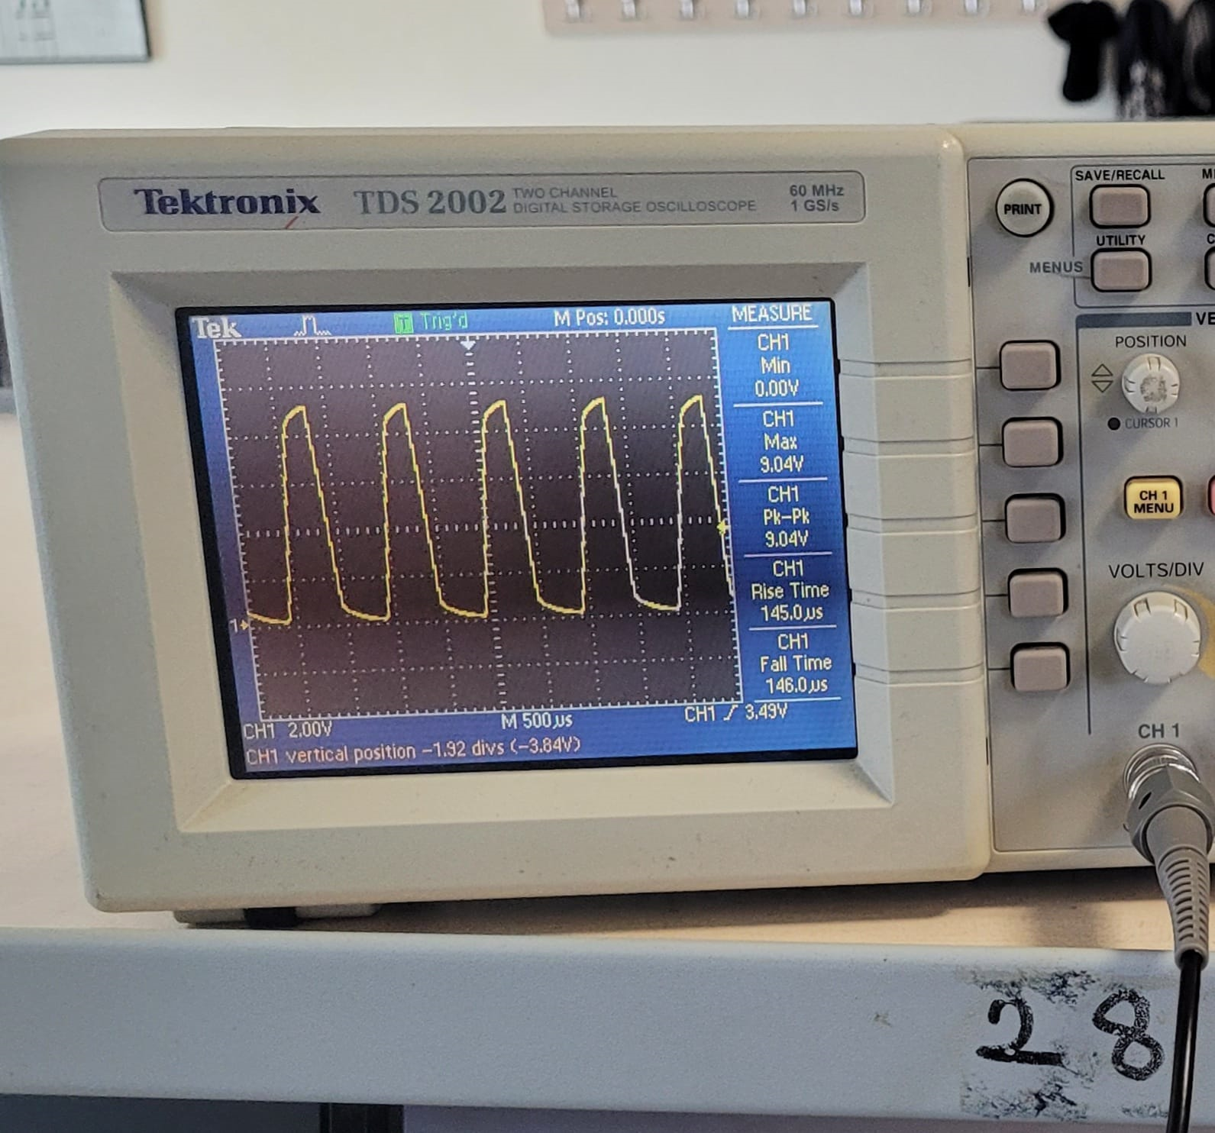

Figure 6: Saturated Output of OPAMP

When 200k ohm is used for R2 the OPAMP’s output saturated visibly which meant I needed to replace the resistor with a lower resistance value. This means more than 35 $$μA$$ is supplied to the photodiode. Through trial and error where I tried 100k, 68k and 47k Ohms in order, the circuit stopped saturating once 47k Ohm was implemented. The OPAMP’s output in this case can be seen in figure 7.

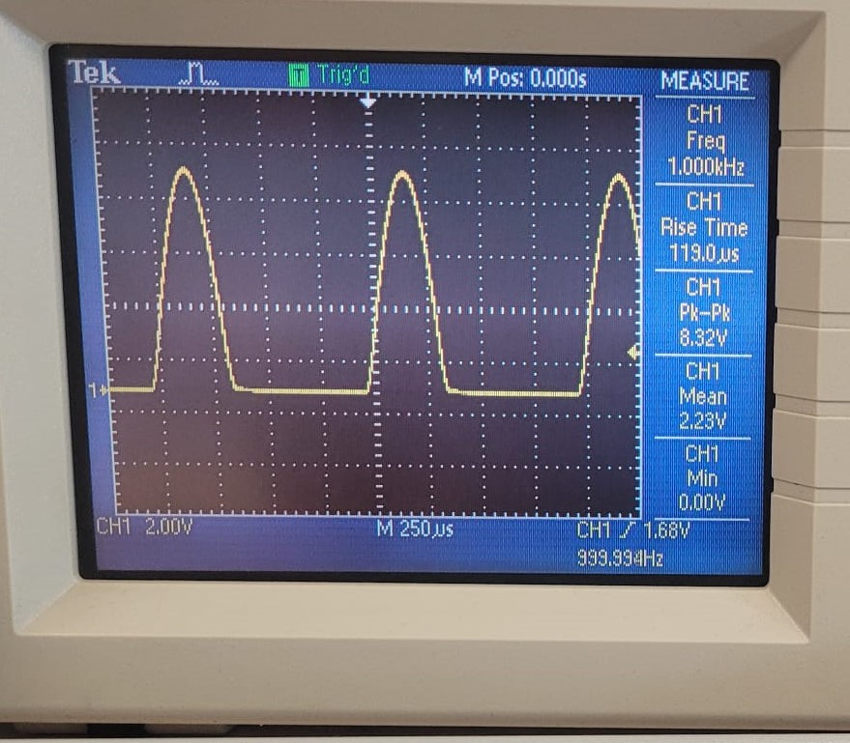

Figure 7: Non saturated OPAMP Output:

As can be seen in figure when $$R2 = 47k Ohm$$ one can see a half rectified sinusoidal wave where $$\max{} V_{opamp}=8.32V$$ and $$mean V_{opamp}=2.23V$$. From this we can also calculate the current caused by the photodiode. By using the mean value of the OPAMP’s output. From Ohm’s Law:

$$I_{photo}=\frac{meanV_{opamp}}{R2}$$

Which equals $$I_{photo}=47.44μA$$. This supports the idea that the current supplied to the photodiode is higher than $$35μA$$ on average.

For the case of saturation, one should look at the max voltage output as the saturation occurs at these points. Hence, Ohm’s law changes into,

$$I_{photo}=\frac{\max{V_{opamp}}}{R2}$$

From this $$I_{photo}=177.02μA$$. Considering this max current and assuming the OPAMP is ideal one can change R2 up to $$R2=56.487⋅{10}^{3}Ohm$$ theoretically. In the real case, it would be different as in figure 6 saturation started occurring before OPAMP’s output reached 10 volts (it was visibly saturated at 9.04 V).

1. Choice of R3C1 and Ripple Approximation

Before the calculations for RC, one needs to decide on whether $$τ=R_{3}C_{1}$$ needs to be bigger than the period of the input or smaller than it. If it were smaller, the capacitor would discharge fully towards $$R_{3}$$ which would eliminate the chance of acquiring DC voltage. The diode blocks the chance of current flowing towards the OPAMP

If $$τ$$ is bigger than the period of the input, which is $$1⋅{10}^{−3}s$$, the capacitor will not be able to discharge fully, and it will start charging back up. As a result of this reaction the output voltage will fluctuate between two values: peak at the end of charge and bottom at the end of discharge. The goal here is to decrease this fluctuation as much as possible to have a stable voltage at the output.

It should also be noted that the capacitor in this circuit behaves like a filter capacitor that shuts of the rectified sinusoidal wave.

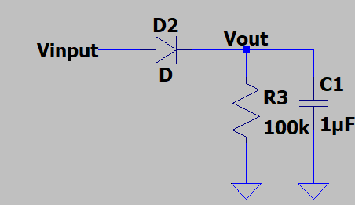

Figure 8: Representative Circuit

One can say the equation at maximum Vout is,

$$V_{out}\left(t\right)=V_{max}⋅e^{−\frac{t}{τ}}$$

Where t is the time after output voltage From here we can find the lowest voltage as

$$V_{min}=V_{max}⋅e^{−\frac{T}{τ}}$$

Where T is the discharge time. The ripple, which is the fluctuation that was mentioned, from here can be calculated:

$$V_{max}−V_{min}=V_{max}−V_{max}⋅e^{−\frac{T}{τ}}$$ $$=V_{max}\left(1−e^{−\frac{T}{τ}}\right)$$

We need discharge time T to be smaller than $$τ$$ so that the capacitor can’t discharge more than necessary. If we use Taylor series expansion to the exponential of first two terms we will get:

$$V_{ripple}=V_{max}\frac{T}{τ}$$

As we are aiming for a small ripple effect, we can approximate T as the period of the input voltage [1]. In such case final equation turns into:

$$V_{ripple}=V_{max}⋅\frac{T_{input}}{τ}$$

For this I picked $$R_{3} = 100k ohm$$ and $$C_{1} =1μ Farad$$. This makes $$τ= 1⋅{10}^{−1}s$$ whose period is 100 times of the input’s period.

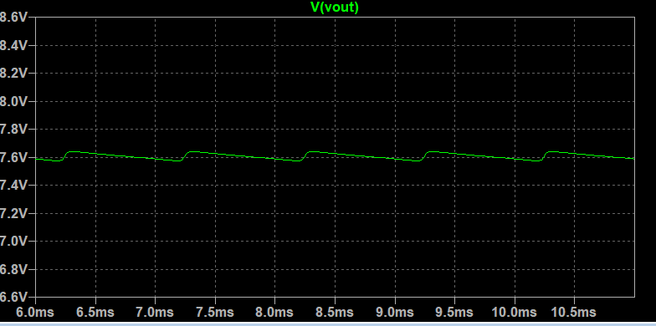

Figure 9: Representative result for 8.3sin(2 $$π$$\*1000).

Given that a similar input 8.3sin(2 $$π$$\*1000) is given we expect voltage to be around 7.6 Volts

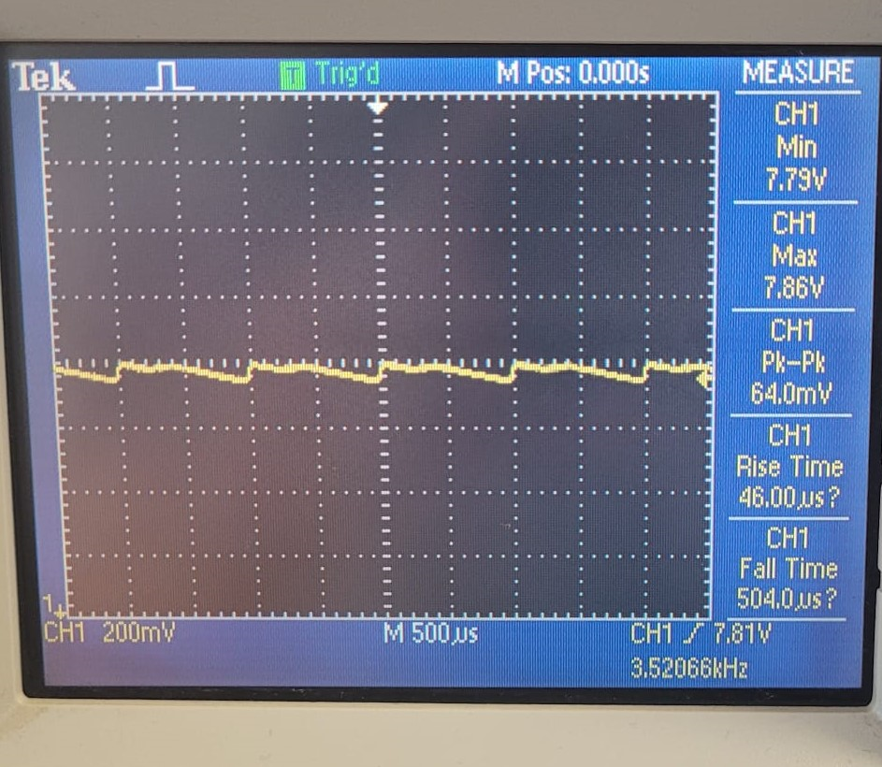

Figure 9: Ripple effect and DC output

As one can see there is an average voltage value of 7.82V and $$V_{max}= 7.86V$$ from Vmax we expect $$V_{ripple}= 78.6mV$$. However, the ripple is 18% lower than expected which is better as the ripple effect measured being smaller ensures the stability of DC voltage.

The voltage loss between output of the OPAMP is likely caused by the threshold voltage of the used diode. Moreover, the loss is less on the hardware compared to software example which is due to difference of inputs as in hardware we use half rectified sinusoidal wave.

Conclusion:

In this lab I learnt how to utilize a LED and a photodiode that works on a nonvisible wavelength to create a system like a remote control. Then I used OPAMP to turn the current created by the photodiode to voltage source. The main challenge here was to find how much current was passing through the photodiode as the current created by this component was not a one changing value. Though measuring after one wrong resistor may seemed like a good idea at first, I decided not to follow this route as I was not sure whether current calculated or measured on a saturated OPAMP would yield accurate results. This led me to use a trial-and-error method until I found a better value.

For the RC circuit the harder part was to measurement of ripple voltage as many $$τ$$ that is about 4 to 5 times than the period of the input would start giving outputs that was more or less similar to that of DC voltage. To ensure success I decided to go a bit higher than the minimum time constant value I could pick and then calculated the ripple voltage from there. The errors in this may have been caused by the oscilloscope or the capacitor not having the exact value of $$1μ Farad$$.

Sources

[1] D. Neaman, *Microelectronics Circuit Analysis and Design*. McGraw-Hill Science Engineering, 2007.

[2] 5mm Photodiode PD333-3B/H0/L2, <https://www.mouser.com/datasheet/2/143/EVER_S_A0003536626_1-2548659.pdf> [accessed Sep. 30, 2023].

[3] Strong Base Investment Ltd., <https://cdn.ozdisan.com/ETicaret_Dosya/399471_5628559.PDF> [accessed Sep. 30, 2023].